Name: Karan R
Domain: Data Analyst
Project: Power BI Snapdeal Project
Task 4: From the dataset, suppose higher discounts don’t necessarily lead to higher ratings. How would you prove or disprove this In Power BI using measures and visualizations?
Answer:
The relationship between Discount and Customer Rating was evaluated using a combination of aggregated analysis and product-level visualization in Power BI.
Visuals Used:
- Average rating by Discount Range (column chart)
- Discount vs Rating (scatter plot)

Explanation:
To analyze whether higher discounts result in higher customer ratings, discount values were first grouped into meaningful discount ranges (0-10%, 10-30%, 30-50% and 50%+). A column chart was then used to display the average rating for each discount range.

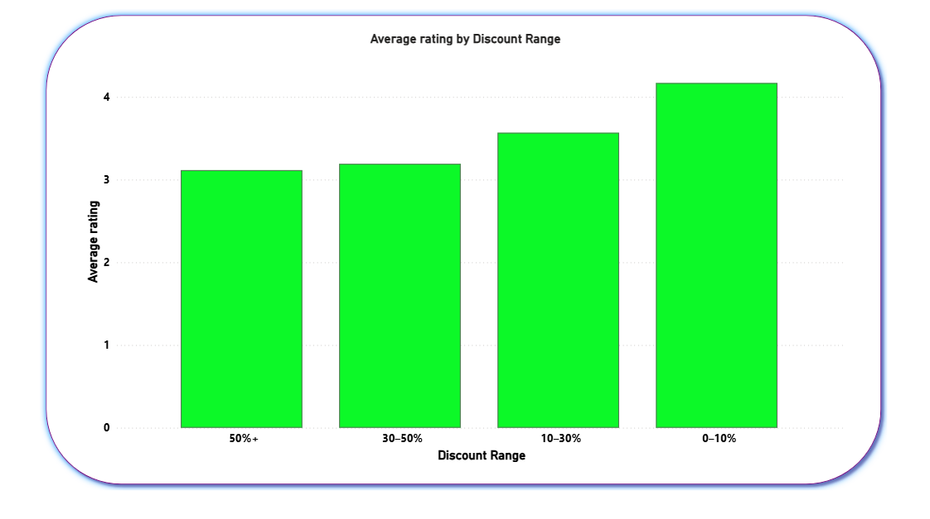

From the chart, it is clearly observed that products with lower discounts (0-10%) have the highest average ratings, while products with higher discounts (50%+) show lower average ratings. This indicates that increasing discounts do not consistently improve customer satisfaction.
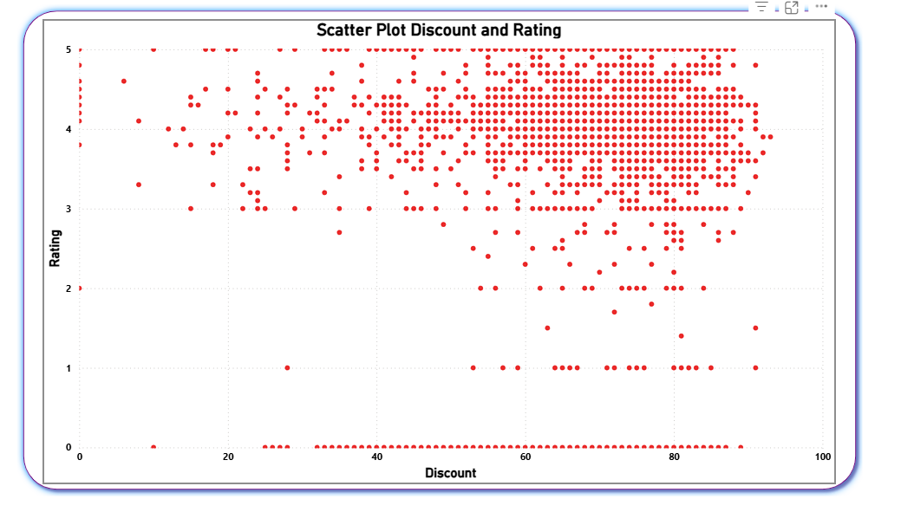

To further validate this finding, a scatter plot was used with discount on the X-axis and rating on the Y-axis, where each point represents an individual product. The scatter plot shows a widely dispersed distribution of ratings across all discount levels, with no clear upward trend as discounts increase. Even at higher discount percentages, ratings vary significantly and include many low and moderate values.

Interpretation:
The combined insights from both visuals demonstrate that higher discounts do not necessarily lead to higher customer ratings. While discounts may attract purchases, customer satisfaction appears to be influenced more by factors such as product quality, brand trust, and value perception rather than price reductions alone. In fact, heavy discounts may sometimes be associated with lower-rated products, possibly due to clearance sales or lower-quality items.

Conclusion:
Using both average-based analysis and product-level scatter analysis, the Power BI visuals clearly disprove the assumption that higher discounts automatically result in better customer ratings. This highlights the importance of focusing on product quality and customer experience alongside pricing strategies.

